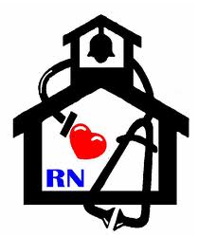
Nurse’s Nook
Pearl Lower Elementary – December
Aly Weems, School Nurse
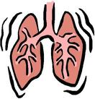 How Smoking Affects Asthma 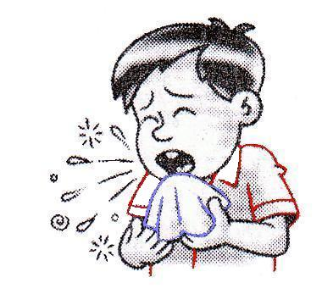
Smoke from cigars, cigarettes, and pipes harms your body in many ways, but it is especially harmful to the lungs of a person with asthma. Tobacco smoke is a powerful trigger of asthma symptoms.
How does tobacco smoke trigger asthma? When a person inhales tobacco smoke, irritating substances settle in the moist lining of the airways. These substances can cause an attack in a person who has asthma. In addition, tobacco smoke damages tiny hair-like structures in the airways called cilia. Normally, cilia sweep dust and mucus out of the airways. Tobacco smoke damages cilia so they are unable to work, allowing dust and mucus to build up in the airways. Smoke also causes the lungs to make more mucus than normal and this can also lead to an asthma attack.
Is secondhand smoke harmful to a person with asthma? When a person with asthma is exposed to secondhand smoke, he or she is more likely to experience the wheezing, coughing, and shortness of breath associated with asthma.
Can smoking harm my child? Secondhand smoke harms children with asthma even more than adults. When a child is exposed to tobacco smoke, his lungs become irritated. Since children’s airways are smaller, the side effects of secondhand smoke affect them faster and can also affect lung function in later life. Children of parents who smoke are also more likely to develop lung and sinus infections. These infections can make asthma symptoms worse and more difficult to control.
Can smoking harm my unborn child? Children of mothers who smoked during pregnancy are more likely to have lung problems and 10 times more likely to develop asthma. Smoking during pregnancy has also been linked with low-birth weight newborns, premature births, and SIDS.
How can tobacco smoke be avoided?
-If you smoke, quit. Quitting isn’t always easy, but there are many programs and methods to help. Ask your health care provider to help you find the one that is best for you. If your spouse or other family members smoke, help them understand the dangers of smoking and encourage them to quit.
-Do not allow smoking in your home or your car.
-Do not let anyone smoke around you or your child.
-Avoid restaurants and public places that permit smoking.

